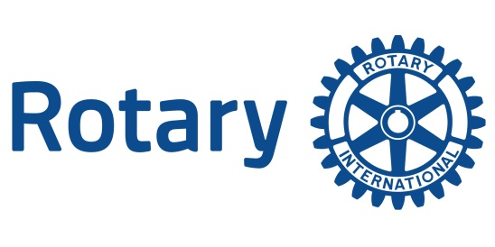
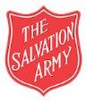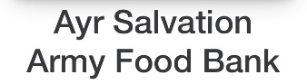
Club of Ayr
Club of Ayr

ANNUAL CHARITY GOLF DAY

FRIDAY 5th MAY 2023

This year the main beneficiaries are:

- Ayr Salvation Army Food Bank – providing essential food supplies to the needy
- The Gaiety Youth Theatre – offering free places to those who cannot afford to pay

We are entering a team this year at a cost of £220.00 Yes / No
We wish to sponsor a hole at a cost of £125.00 Yes /No

COMPANY/ TEAM NAME ______________________________________________________
ADDRESS ______________________________________________________
______________________________________________________

CONTACT NAME _______________________________________________________
TELEPHONE NUMBER __________________________________________________________
E-MAIL ADDRESS _______________________________________________________

Bank Transfer to 801239 00114287 Account name is Ayr Rotary Club (Benevl Fd)". Please quote the Team Name!!

Please return this form (and cheque if you cannot use BACS) by post or email to:

Charlie Steele, 57 Auchendoon Crescent, Ayr KA7 4AT (Telephone 07880 554614)
Email : golf@rotaryclubofayr.org

…………………………………………………………………………………………………
Maximum Playing Handicap – Men 28, Women 36. Handicaps will be based on your handicap index.
In the absence of a Scottish Golf handicap, the maximum will be 18 for Men, 26 for Women.
STABLEFORD RULES APPLY - FULL HANDICAP WILL BE USED.

Scoring will be on the basis of the two best net points scores of the team for all eighteen holes.

Shotgun Start at 9.30am. Please complete play by 1.30pm.

District 1230 Club No.357 Chartered 1931, Member Club of Rotary International
The Rotary Club of Ayr Benevolent Fund, a registered charity No. SCO13822

